Assignment-2.1

D.Nithya

2303A52457

B-35

Task 1: Statistical Summary for Survey Data Scenario:

You are a data analyst intern working with survey responses stored as

numerical lists.

* Task:

Use Google Gemini in Colab to generate a Python function that reads a list

of numbers and calculates the mean, minimum, and maximum values.

Output:

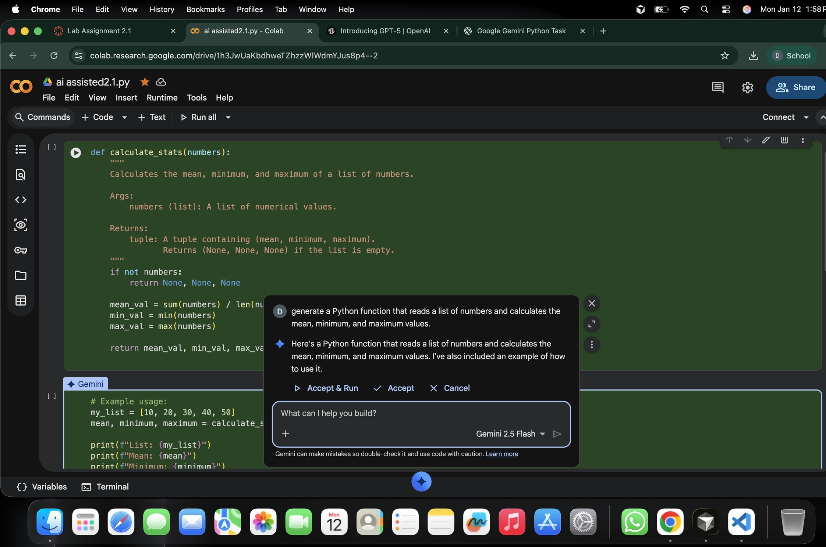Screenshot of Gemini prompt and result

Correct Python function Output shown in Colab

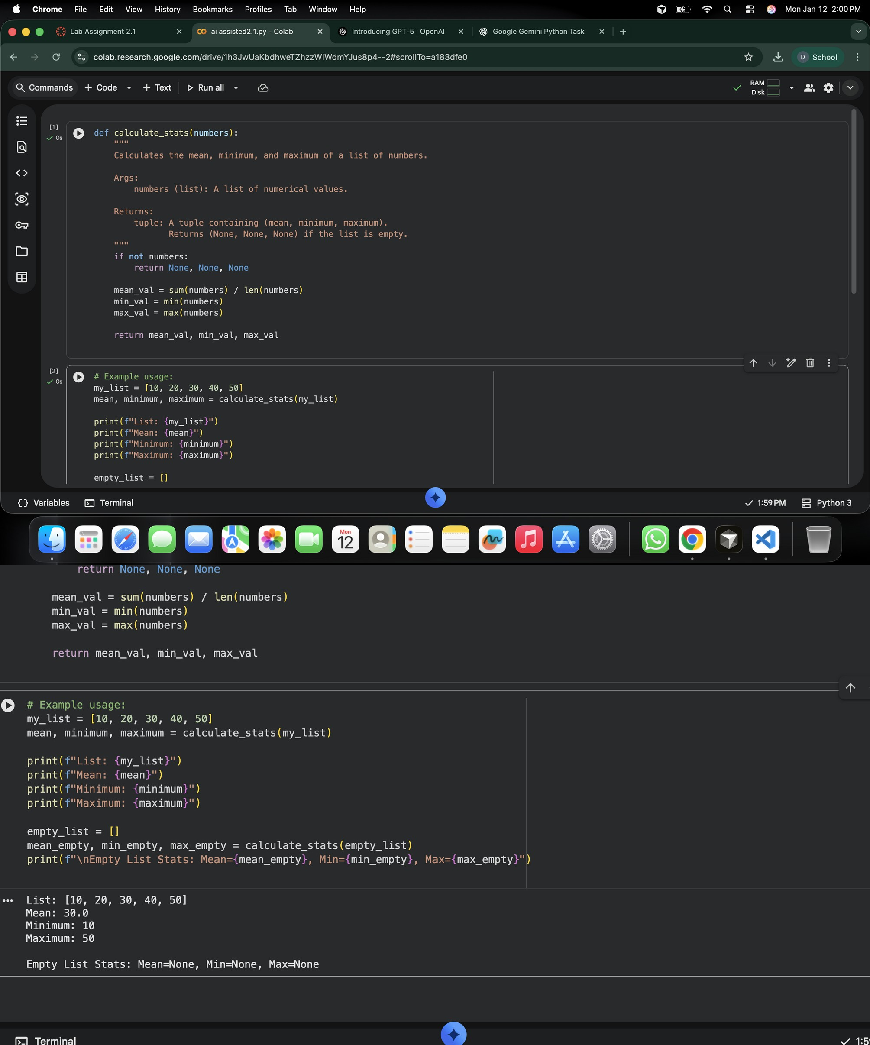

Task 2: Armstrong Number – AI Comparison

* Scenario:

You are evaluating AI tools for numeric validation logic.

* Task:

Generate an Armstrong number checker using Gemini and GitHub

Copilot.

Compare their outputs, logic style, and clarity.

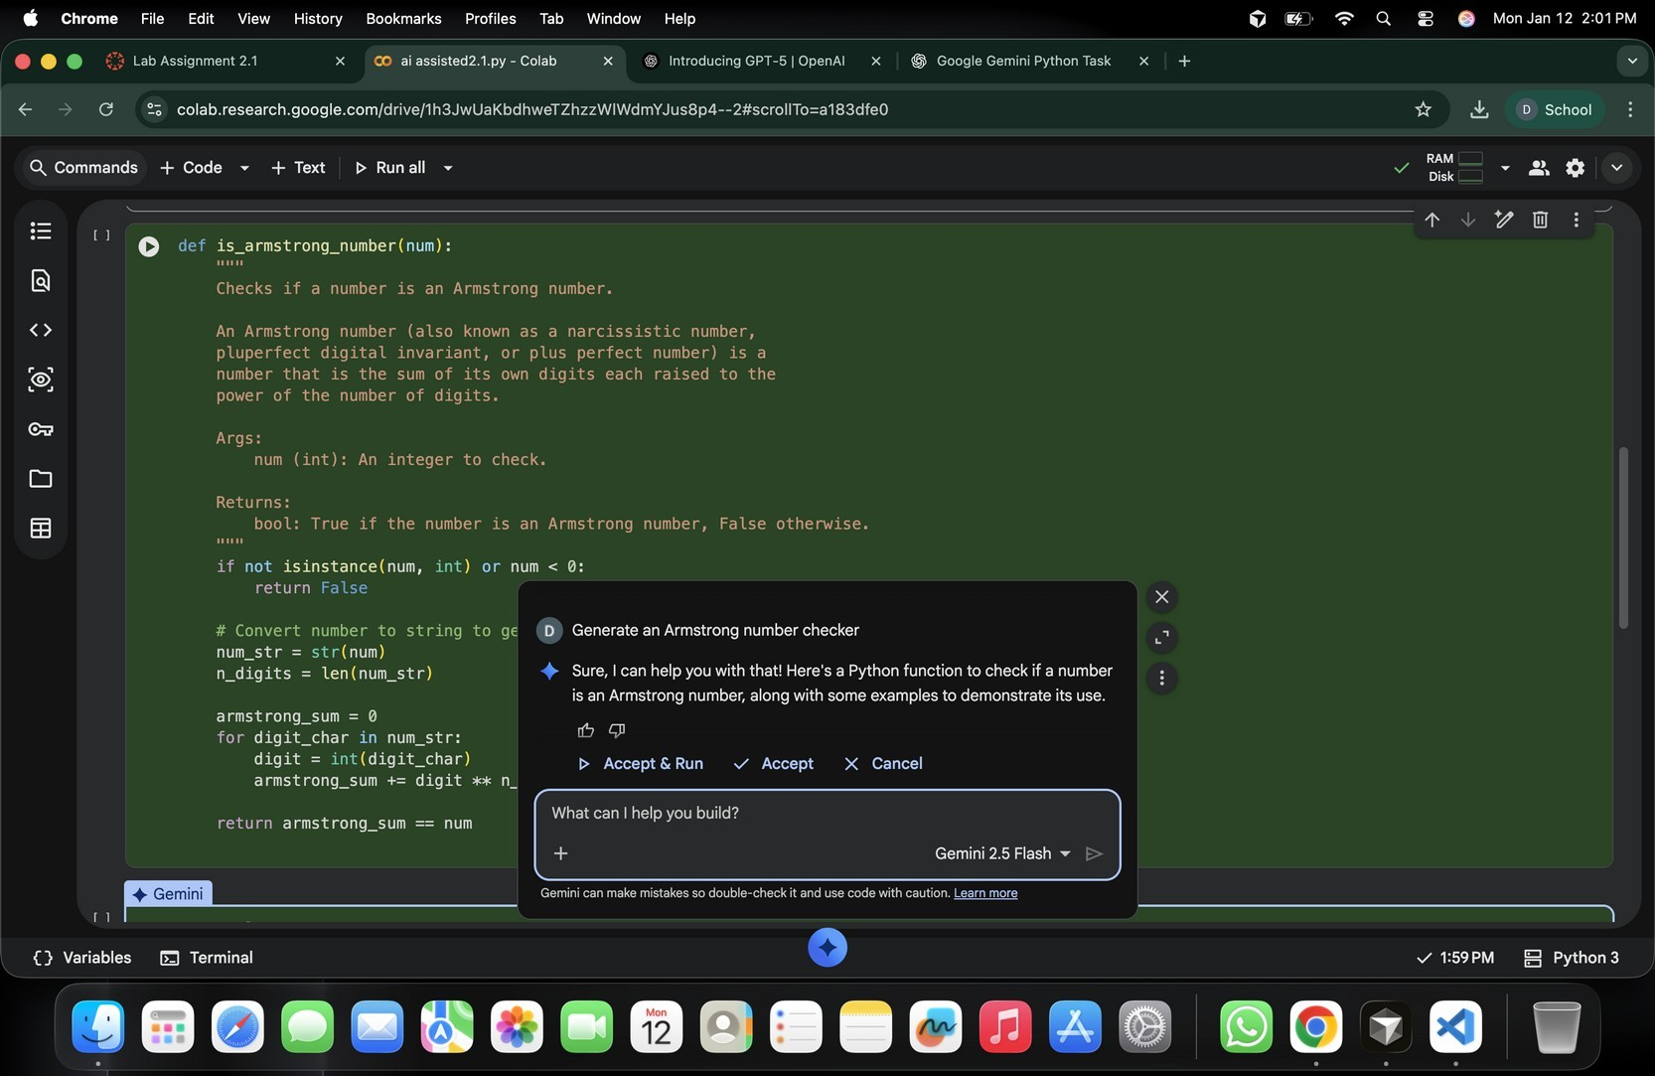

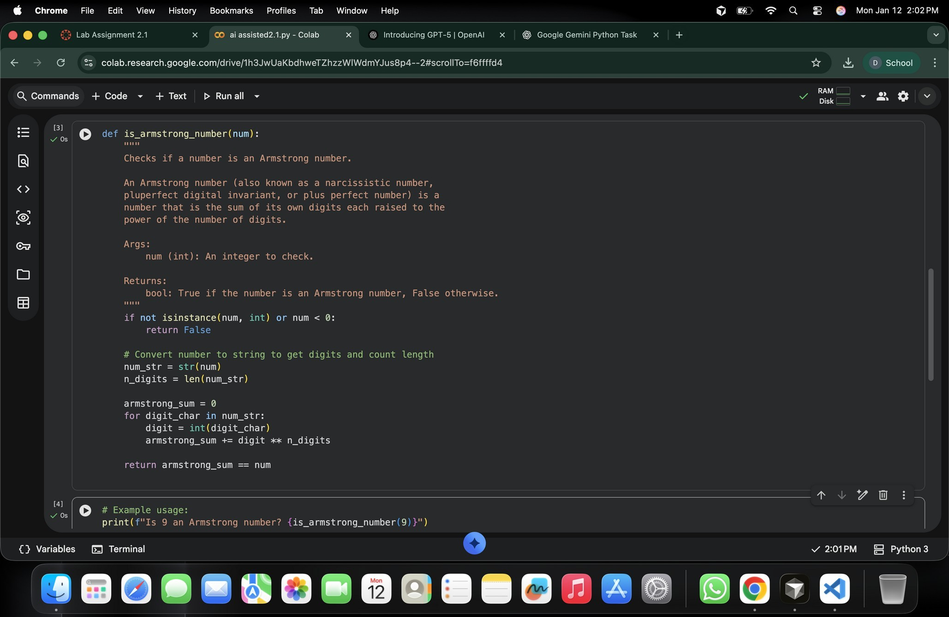

Using vs and GitHub copilot

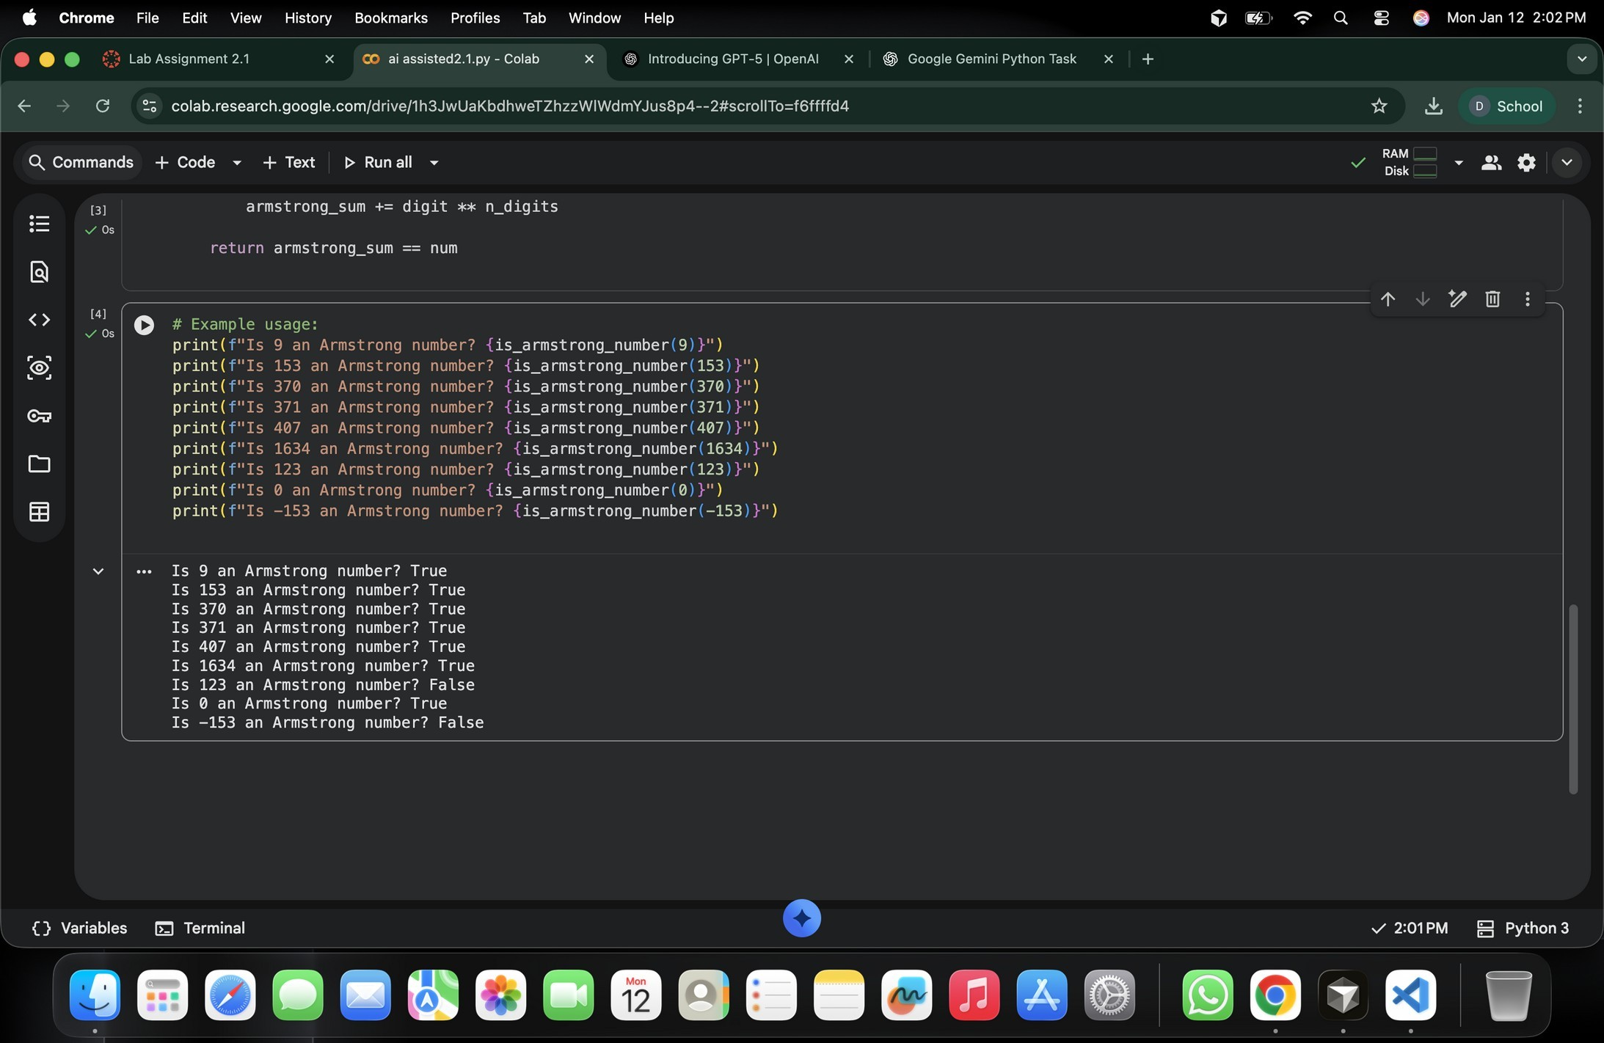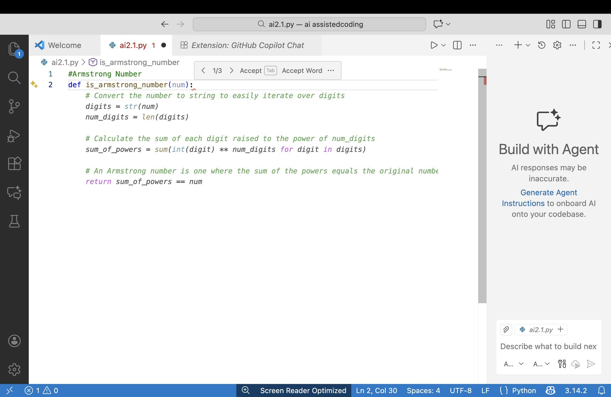

Task 3: Leap Year Validation Using Cursor AI

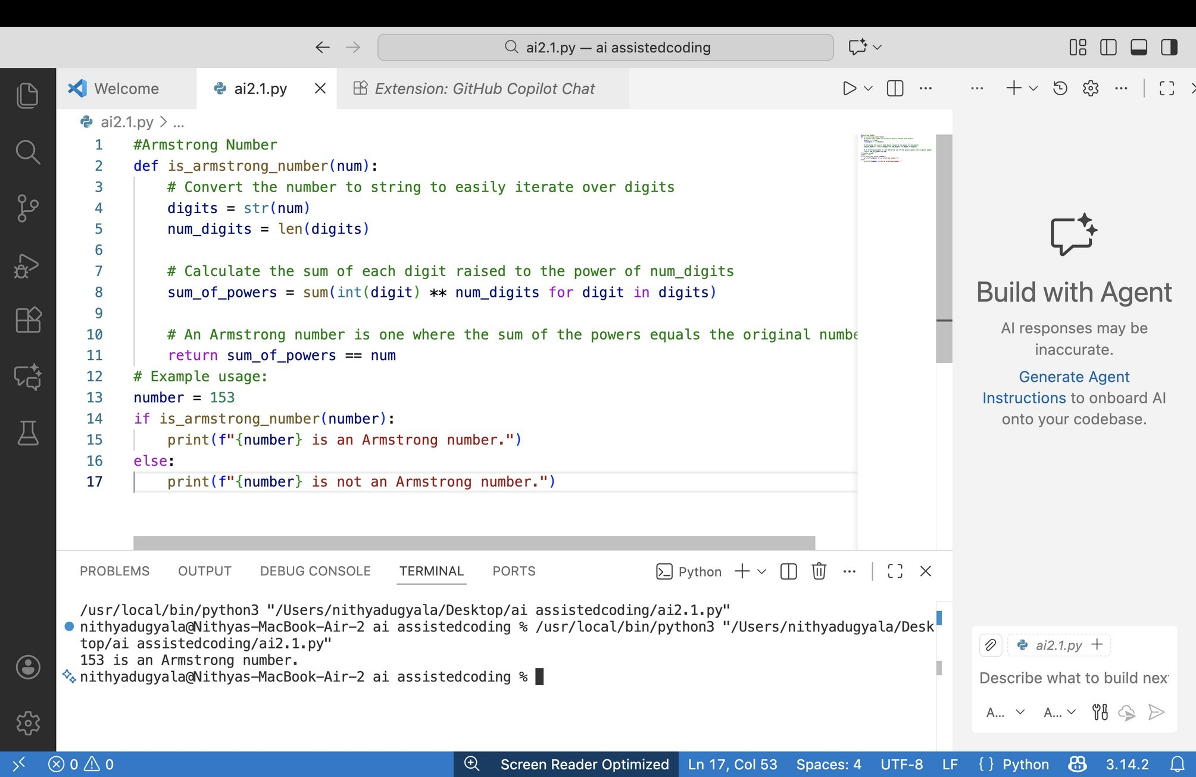

* Scenario:

You are validating a calendar module for a backend system.

* Task:

Use Cursor AI to generate a Python program that checks whether a given

year is a leap year.

Use at least two different prompts and observe changes in code.

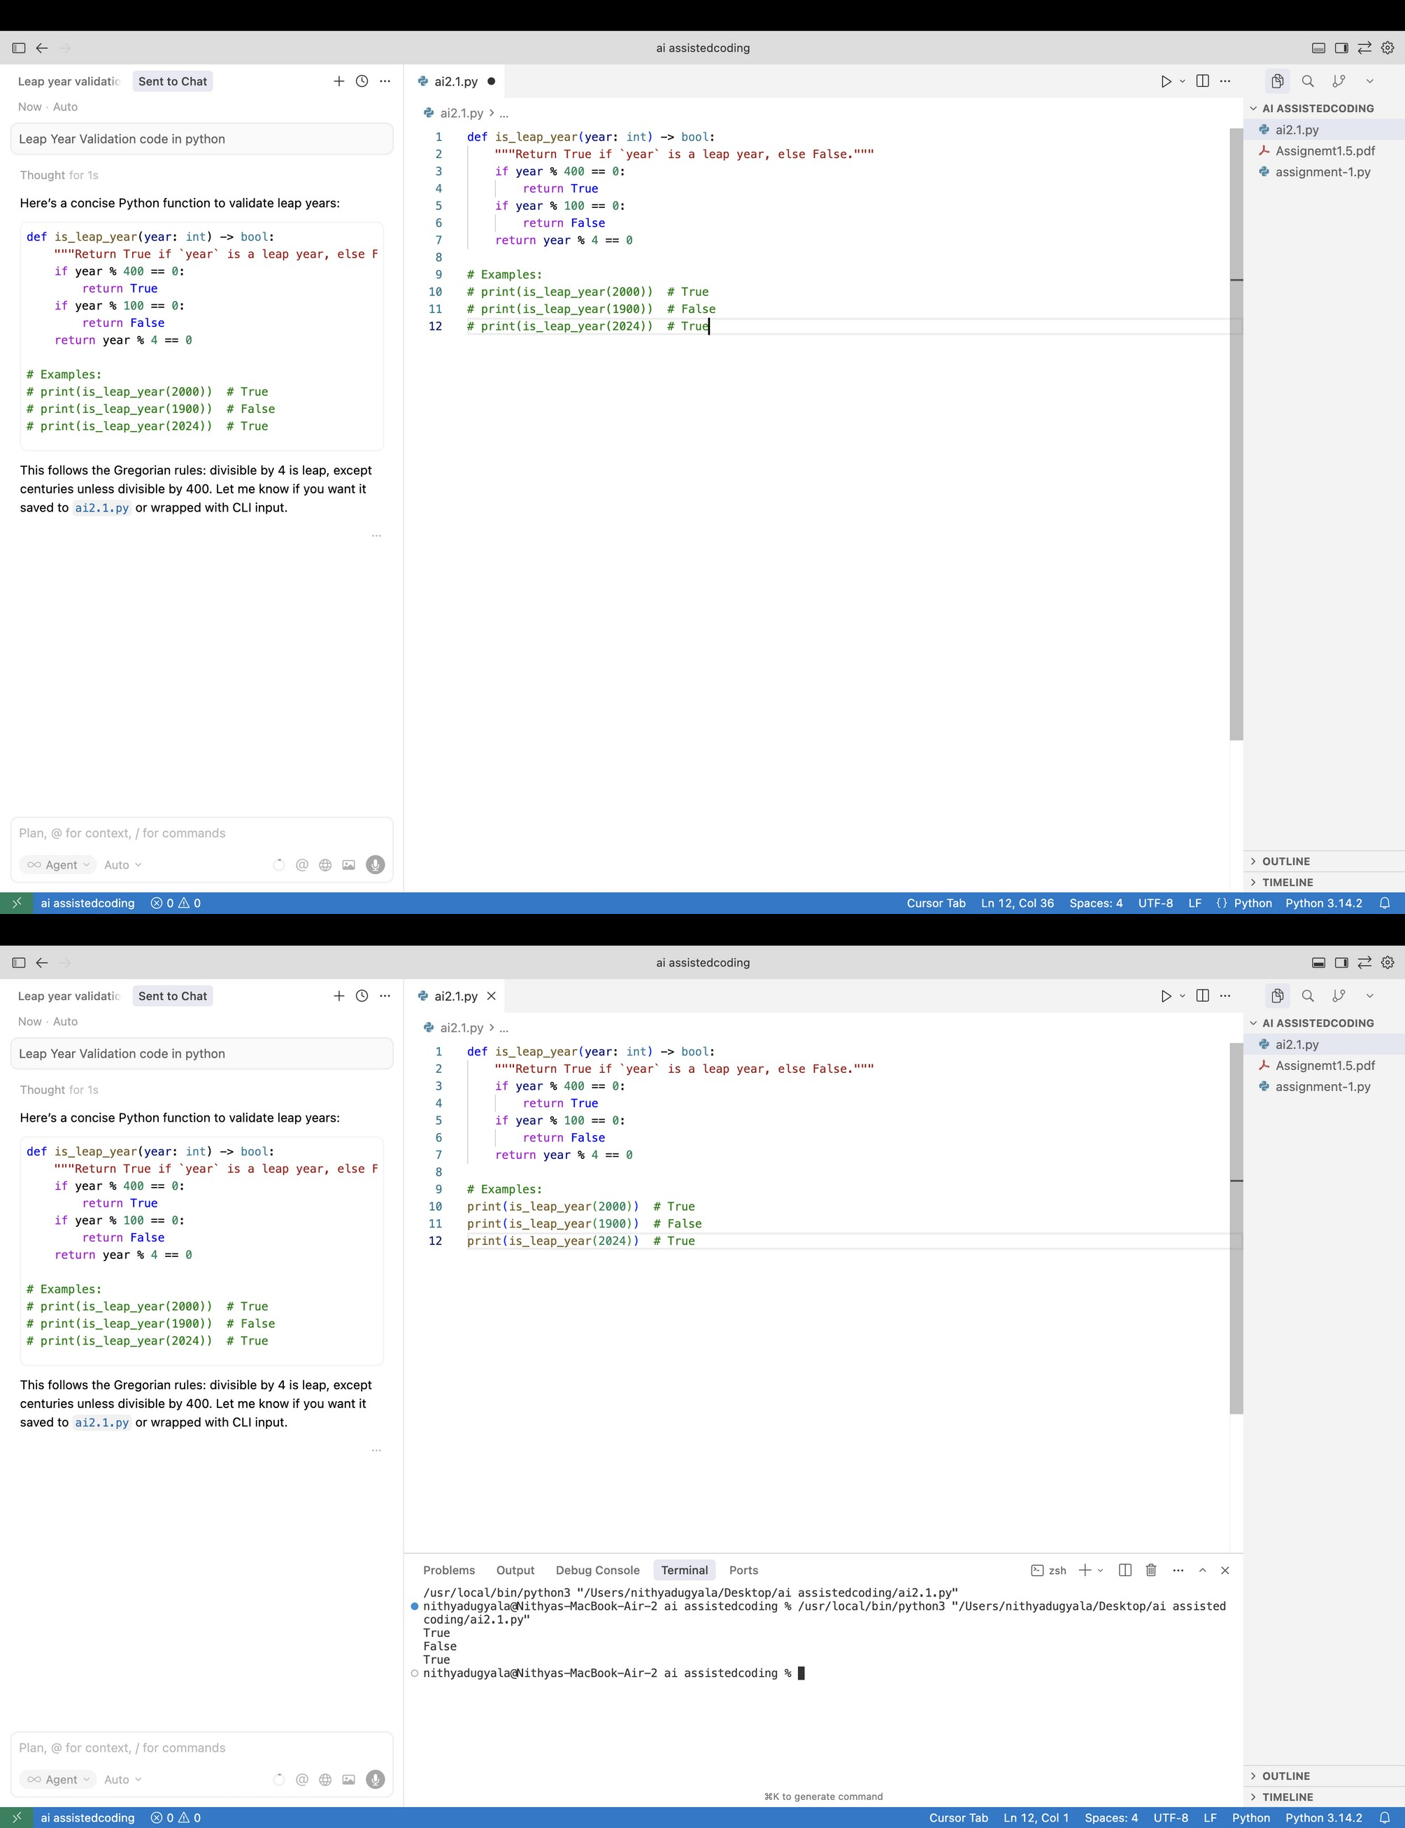

Other prompt:

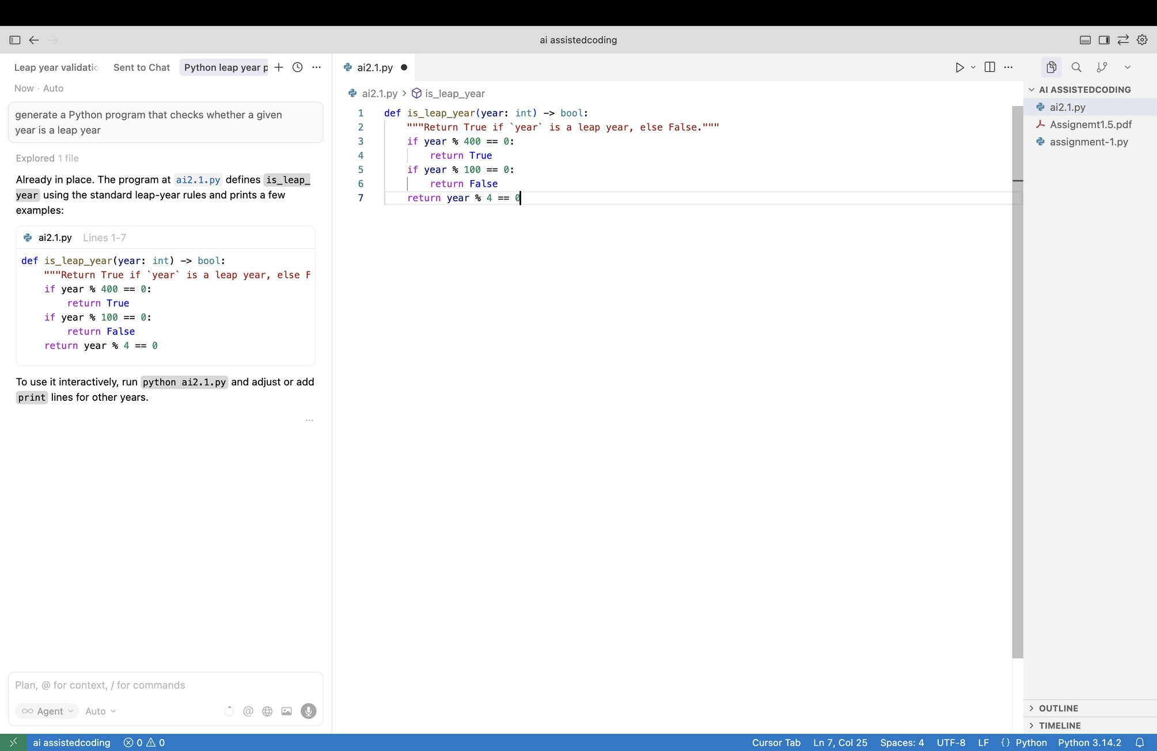

task 4: Student Logic + AI Refactoring (Odd/Even Sum)

* Scenario:

Company policy requires developers to write logic before using AI.

* Task:

Write a Python program that calculates the sum of odd and even numbers

in a tuple, then refactor it using any AI tool. Expected Output:

* Original code
* Refactored code
* Explanation of improvements

